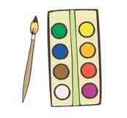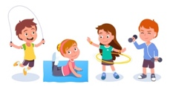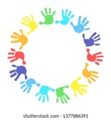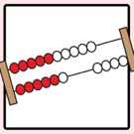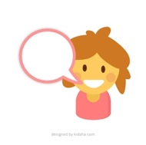**

**Expressive Arts and Design**

CREATE a painting, being inspired by famous artists.

PERFORM a story, song, poem or rhyme to an audience.

**Understanding the World**

KNOW their own family tree.

CARE for an animal.

APPRECIATE different religious and cultural communities in their local area and around the world.

UNDERSTAND how to read a simple map.

**Mathematics**

UNDERSTAND in depth numbers to 10, including number bonds to 10.

RECOGNISE the pattern of the counting system.

COMPARE quantities in different contexts.

SUBITISE confidently.

**Literacy**

RETELL a story through play.

READ simple sentences and books containing taught graphemes.

WRITE simple phrases and sentences that can be read by others.

**Physical development**

USE simple tools with confidence.

HOLD a pencil effectively.

RIDE a two-wheeled bike.

**Personal, social and emotional development**

Show EMPATHY towards others.

Show DETERMINATION to complete a goal.

Show RESILIENCE in the face of challenges.

Show CURIOSITY about the world around them.

Feel HAPPY and SECURE to talk about their feelings with their friends and teachers.

**Communication and Language**

ASK a relevant question, make a relevant comment.

CONVERSE in a back-and-forth conversation with friends and teachers.

EXPRESS their ideas and feelings with confidence.

Our curricular goals highlight all the things that we want children to know, experience and be able to do as a result of their time in Reception. Much of the time the children will guide their own learning, but we are mindful of the outcomes we want our children to reach and how we can support our children in achieving them.

***Our Curricular Goals***

**2023 - 2024**